30.67: a) Just after the switch is closed there is no current through either inductor and they act like breaks in the circuit. The current is the same through the 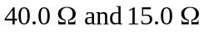 resistors and is equal to
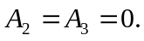
b) After a long time the currents are constant, there is no voltage across either inductor, and each inductor can be treated as a short-circuit . The circuit is equivalent to:
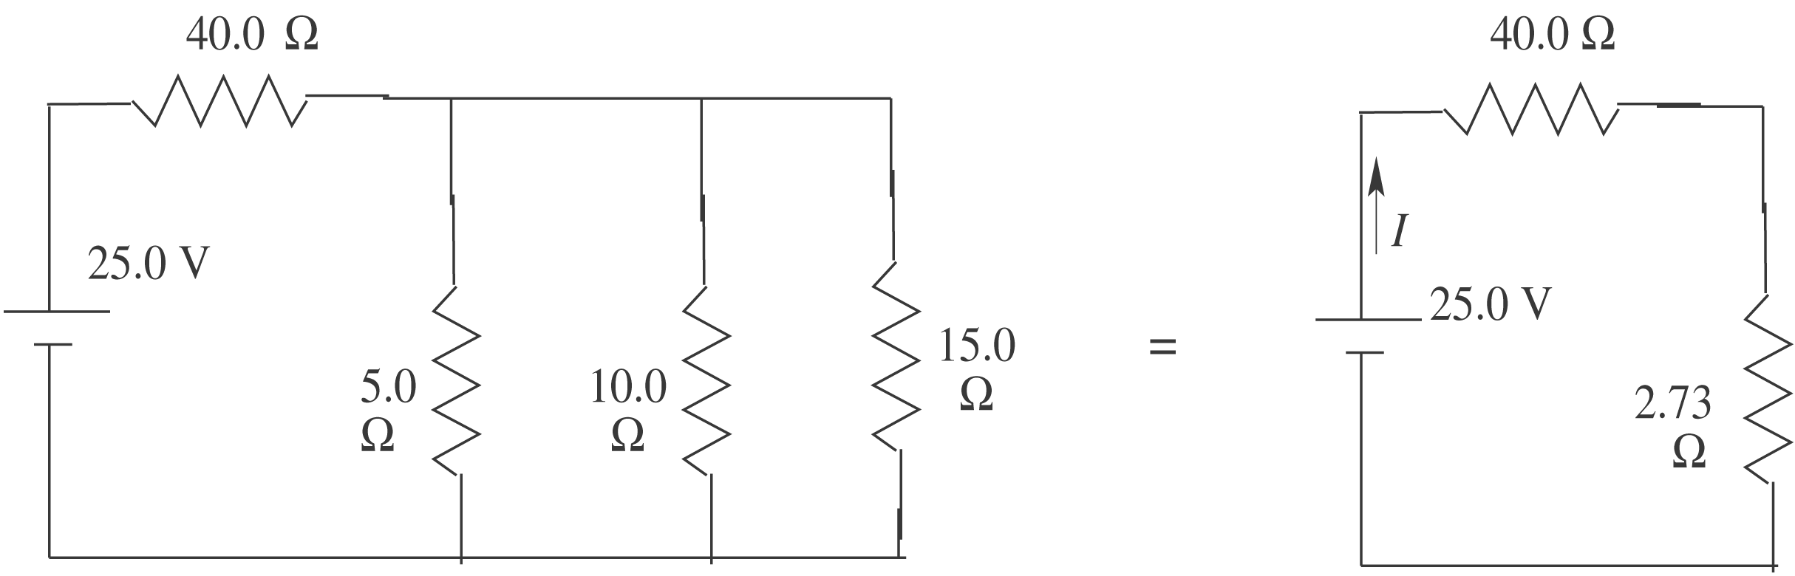
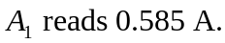 The voltage across each parallel branch is 